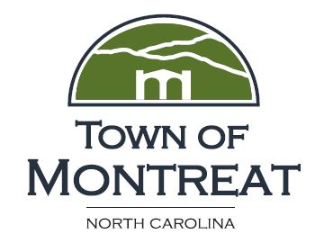

Town Forum
Agenda
October 17, 2022 6:30pm

- Call to Order
- Welcome
- Moment of Silence

- Agenda Adoption
- Introduction
  - Purpose of Forum
  - Purpose of bear related initiatives
- Review of new ordinances and ordinance revisions and discussion of what they mean
- New: Release of Hunting Dog Ordinance
- New: Trespass Ordinance
- New: Ordinance Prohibiting Feeding of Bears
- Revised: Dog Control Ordinance
- Revised: Solid Waste Ordinance

- Other measures taken as part of initiative
  - Police presence and response
    - Brief comments by Chief Arrant
  - Security cameras
  - Change in waste/recycle disposal policy
  - Town/MMBHC partnership
  - Bearwise presentation/recording
  - Communicating to property owners
- Your rights and responsibilities
- What to do if you are involved in a bear/hunter/dog incident
- Public Questions and Comments
- Adjournment

