Board members present: Mayor Tim Helms

Mayor Pro Tem Tom Widmer

Commissioner Jane Alexander

Commissioner Kent Otto

Commissioner Alice Lentz

Commissioner Kitty Fouche

Board members present via

Zoom: None

Board members absent: None

Town staff present: Alex Carmichael, Town Administrator

Angie Murphy, Town Clerk

Town staff present via Zoom: None

Several members of the public were present at Town Hall and several more were watching via Zoom. Mayor Helms called the meeting to order at 7:00 p.m., and led the group in the pledge of allegiance and a moment of silence.

**Agenda Approval**

Commissioner Kitty Fouche moved to approve the agenda as presented. Mayor Pro Tem Tom Widmer seconded and the motion carried 5/0.

**Presentations & Reports: FY 21-22 Budget Presentation**

Mr. Carmichael advised that the balanced FY 21-22 Budget was published last week. The proposed FY 21-22 General Fund budget totals $1,810,952. This is a 2% increase from the current year budget, but an 8.34% decrease over the prior fiscal year. The proposed FY 21-22 Water Fund Budget totals $344,041, which is a 10.54% increase over the current year, but a 15.51% decrease from the previous year’s budget. The combined budgets total $2,154,993 which represents a 3.29% increase over the current year, and a 9.52% decrease over the prior fiscal year.



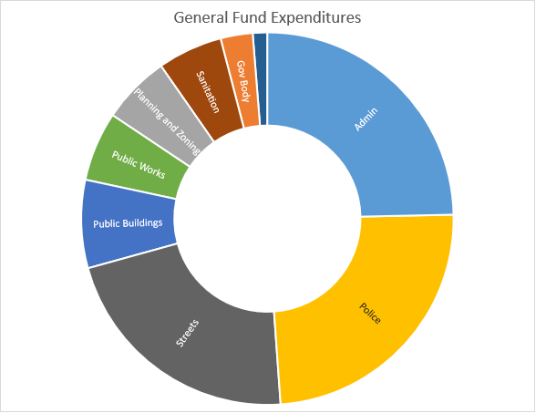

The chart presents the relative size of the budget by department. The unlabeled sliver represents the Recreationa and Environment Departmant.

Capital Projects included are the Comprehensive Plan Update ($30,000), the Texas Road Bridge Conversion ($102,603), the Texas Culvert Barrel 1 ($35,750) and the Arbor Lane Bridge ($10,441). The last two projects only account for the Town’s 25% of the project total and the remaining 75% would come from the State of North Carolina for Tropical Storm Alberto repairs.

Captial Projects not included are the Municipal Software Replacement ($91,683) and Local Streets paving on Oklahoma Rd ($150,700), New Road paving on Upper Oklahoma Rd ($97,900), Waterline Replacement on Oklahoma Rd ($57,820) and the Tractor Replacement ($45,000).

Other accomplishments in the budget are a 2.25% COLA (cost of living adjustment) raise for staff, an up to 3% Merit raise for staff, fully funds increase budget requests from the Landcare Committee and fully funds increased budget requests from the Tree Board.

A note about the ARPA (American Rescue Plan Act) Funds, which are not included in this budget, are that it will be an estimated $250,000. There are certain things the funds can be and cannot be used for and at this time it has not been published. Eligible projects will likely include: waterline infrastructure, revenue replacement (a specific forumla will be provided to replace revenue lost during the pandemic), public safety salaries and possibly software replacement. ARPA funds cannot increase fund balance, cannot pay down debt or increase pension allotments.

Mayor Pro Tem Tom Widmer expressed his opinion regarding COLA and Merit Increases for staff. Mayor Pro Tem Widmer agrees on one or the other but not both. It raises the base salary rate by 2.25% which Mayor Pro Tem Widmer does not feel is right.

Commissioner Kent Otto asked about the stipulations for accepting ARPA Funds. Mr. Carmichael advised that there will be a lot of reporting stipulations. An example is that the funds cannot be co-mingled with general funds. Commissioner Otto also does not agree with the idea of a COLA either. Commissioner Otto stated that they had a fudiciary right to take care of the Town as well as the employees.

On June 10th a Public Hearing will be held to allow public comment on the budget.

**Public Comment**

Brendan Hayner-Slattery of 319 Assembly Drive thanked everyone for their hard work on the budget preparation. Mr. Hayner-Slattery was concerned about small percentage allotted in the Environment & Conservation Department. Mr. Hayner-Slattery was concerned that the budget for Open Space Conservation was $0 and Greenway Development was $0. In his opinion this makes it clear that the Town cannot bear the costs of any damages that might be done to the environment by construction projects. Mr. Hayner-Slattery stated that the Town can protect itself through ordinances. Mr. Hayner-Slattery mentioned that the Town has the opportunity to add language to protect the Town, the people and the environment.

Priscilla Hayner of 319 Assembly Drive stated that budgets reflect priorities. Ms. Hayner also mentioned that the environment is at particular risk by upcoming construction. Ms. Hayner suggested for significant sized projects (over 5,000-10,000 feet for instance) that there should be a requirement for an environmental impact study to be done. That could be inserted into the ordinance or it could be added onto the application process. Ms. Hayner feels that the historic built structures are part of what makes up the essence of Montreat. Ms. Hayner felt a symbolic amount could be added to the budget to show that Montreat and its Commissioners are paying attention or showing interest in historic preservation. Ms. Hayner stated that she felt something about historic preservation should be added into the Zoning Ordinance as well.

Anne Hayner of 319 Assembly Drive also feels that the Town is at risk if the environment is impacted by large scaled development. There are ways to think creatively to mitigate or prevent the risks to the Town. A fiscal impact statement could be required for any building permit for a developer to show what the fiscal impact would be on the Town.

**Adjournment**

Mayor Pro Tem Widmer moved to adjourn the meeting. Commissioner Kent Otto seconded and the motion carried 5/0. The meeting was adjourned at 8:06 p.m.

­­­­­­­­­­­­­­­­___________________________________ _________________________________

Tim Helms , Mayor Angie Murphy, Town Clerk