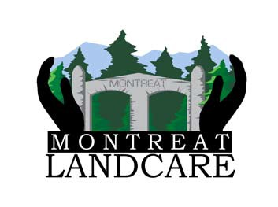
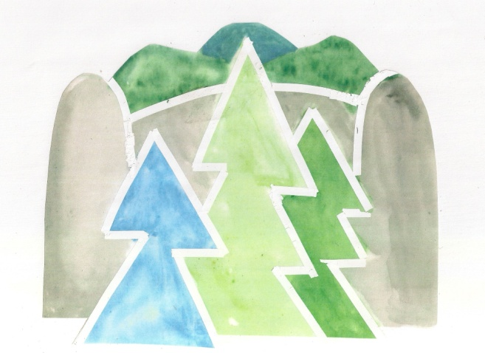
Town of Montreat Tree Board
It’s Time for Spring Cleaning!
The Montreat Landcare Committee, Town’s Tree Board, Firewise Committee and Environmental Commissioner all offer the following for spring yard and leaf clean-up:
1. Rake, blow and bag appropriately and place bags at your driveway for pick-up.
2. Rake, blow and/or mulch your leaves and put in your yard at an appropriate distance from your home. These leaves become a good source of mulch and leaf mold for your gardens. Firewise guidance is that leaves/debris should be at least 30' from the house.
3. As always, keep leaves out of storm drains and the creek as much as possible.
If you would like to hire college students to help with spring yard cleanup, Firewise has received an award from the National Fire Protection Association to help property owners cover the cost of student assistance. Funds are limited (and so is time), so contact Nancy Midgette at midgette@elon.edu.
What happens to my bagged leaves?
Due to the location of the new Public Works Building, the compost/bagged leaf deposit area is no longer available for use by our Public Works department. The Town staff has not yet found a property within the Town limits that meets state restrictions and regulations for this purpose. As a result, bagged leaves are collected from property owners, removed from the bags into the town dump truck, and hauled to a location on NC 9, where they are dumped for a fee of $25.00 per truck load. This same process is used for brush and chipped brush, only delivered to a location on North Fork Road for the same fee per truck load.
The Town is investigating alternatives to the current process. Stay tuned!!!

