Board members present: Mayor Tim Helms

Mayor Pro Tem Tom Widmer

Commissioner Jane Alexander

Commissioner Kent Otto

Commissioner Alice Lentz

Board members present via
Zoom: Commissioner Kitty Fouche

Board members absent: None

Town staff present: Alex Carmichael, Town Administrator
Angie Murphy, Town Clerk
David Arrant, Chief of Police
Barry Creasman, Public Works Director
Darlene Carrasquillo, Finance Officer
Scott Adams, Zoning Administrator

Town staff present via Zoom: None

No members of the public were present at Town Hall but several were watching via Zoom. Mayor Tim Helms called the meeting to order at 1:05 p.m., and led the group in the pledge of allegiance and a moment of silence.

Agenda Approval

Commissioner Jane Alexander moved to adopt the agenda as presented and to suspend the rules to allow the Mayor to participate and debate. Commissioner Kent Otto seconded and the motion carried 5/0.

Community Survey Results and Discussion

Mayor Pro Tem Tom Widmer mentioned that around fourteen months ago discussion swirled around updating the Town of Montreat Comprehensive Plan. Mayor Pro Tem Widmer and Town Administrator Alex Carmichael developed an extensive survey that polled residents and stakeholders on Montreat Today and Tomorrow as well as addressing some issues that arose with the results of the 2008 Comprehensive Plan. The survey was promoted through the Montreat Minute Newsletter and resulted in 235 responses of which 93.3% were property owners. Mayor Pro Tem Widmer advised that he compiled a summary of the 235 responses to review and discuss today. He hopes that these responses can eventually be turned over to a Comprehensive Plan Update Committee to assist in a new plan for the Town of Montreat. Mayor Pro Tem Tom Widmer reflected on the following word cloud that answered the question “What three words/phrases would you use to describe Montreat to others?” The darker the color and the size of the word equates to the more mentions of the words used.

The next question was “How satisfied are with following at Montreat”? with regards to Montreat services. The following table ranks Montreat services on a 5 point scale.

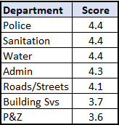

Mayor Pro Tem Widmer encouraged department heads to peruse the comments and address them with staff.

The next question was “How satisfied are you with the performance of the current Town Council?”

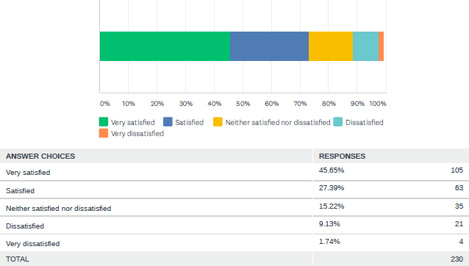

The overall score was 4.1. Mayor Pro Tem Widmer encouraged the Board of Commissioners and Mayor to review the 55 comments associated with “what suggestions for improvement do you have for the Town Council?”

The next question was “What are the three most important issues facing the Town in the next five to ten years?” There were 481 individual responses to this question. Mayor Pro Tem Widmer feels this question is the most important because it is an unaided question.

Issue | Responses
Growth | 109
Infrastructure | 91
Environment | 59
Stakeholder/Other Entities | 27
Fiscal Related | 24
Town Government/Services | 21
Treatment of Others | 21
Safety/Security | 20
Status Quo | 19
Zoning/Regulations | 17

Mayor Pro Tem Tom Widmer reviewed the breakdown of responses with the Commission.

The next question was to rate the importance of the following issues for the Town in the next five to ten years.

Issue | Score
Health of Flat Creek | 4.7
Stormwater and flooding | 4.6
Development/redevelop of land/structures | 4.2
Population growth | 3.9
Attracting younger people as residents | 3.6
Increasing the tax base | 3.3
Offering wider variety of housing to renters | 2.9
Commercial/Retail development | 2.7

The next question on the survey was should the following happen or not in Montreat?
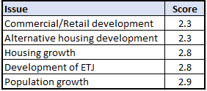

Scale
Must Happen = 5 points Should Happen = 4 points Doesn’t Matter = 3 points Should Not Happen = 2points Must Not Happen = 1 point

Mayor Pro Tem Tom Widmer encouraged the Commission and Staff to really look at the Montreat Today questions and apply them in the day to day operations.

Planning Board Recommendations for Zoning Ordinance Updates

Chairman Bill Scheu briefly explained the process that the Planning & Zoning Commission utilized while working through the proposed ordinance changes. Mr. Scheu explained that the Commission tried to organize and simplify the ordinance for staff and residents alike. Some articles were combined and verbiage was simplified. It is the Commission’s recommendation that the Board of Commissioners review zoning district R3, which is up Greybeard Trail in the ETJ, in a more in-depth manner. With regards to setbacks the Commission discussed them at length but ultimately they decided not to make very many changes. A few changes occurred with double frontage lots in which the Zoning Administrator will be given discretion with setbacks and the side and rear setbacks abutting the Woodlands District which were reduced from 15 feet to 10 feet. The issue of septic tanks versus sewer systems were discussed at length. The Commission resolved that hooking up to the Town’s sewer system was not necessary and utilizing a Buncombe County governed septic tank would be sufficient. Mr. Scheu stated that additional provisions had been added for PUDs (Planned Urban Development or Planned Unit Development) and Conditional Zoning which Mason Blake will explain further later on in the meeting. Another change occurred with regards to setbacks when houses are in a line on one side of the street. The original ordinance required the average of the setbacks on all the houses on the street to determine the setback provision. The proposed changed involves just looking at the setbacks of the two houses on each side of the lot to determine the setbacks. The Commission feels that this will be a cheaper alternative for residents and more appropriate. In the ETJ there is no residential portion that resides in McDowell County and while the P&Z Commission and Board of Adjustment requires a member to be assigned from this area it’s just not feasible. The Commission suggests dropping this requirement while keeping the actual number of members on each Board the same. Mr. Scheu stated that the Commission gave a little more flexibility with regards to parking and signage. The Commission dealt with signs and banners at Montreat College. The proposed ordinance will allow for light pole banners for the College as long as a few restrictions are followed. Mr. Scheu mentioned that the P&Z Commission is still working on the Steep Slope/Hillside Ordinance and the Stormwater Ordinance and will bring those to the Board of Commissioners for review at a later date.

Mason Blake discussed the two new proposed zoning categories as recommended by the Planning & Zoning Commission. The first was Conditional Zoning which is a single-purpose zoning category which overlays the zoning in your specific lot. Mr. Blake gave an example using setbacks. The typical variance requires hardship requirements that may be hard to meet. The Commission feels that Conditional Zoning is very applicable in the Town of Montreat because zoning categories are traditionally useful for similarly conformed lots but there’s not a lot of conformity in Montreat. The lots in Montreat were not designed with zoning in mind and topography can be difficult as well. Conditional Zoning is a vehicle to give some flexibility in the way property owners develop their lots. There is a process that must be closely adhered to for the property owner/applicant. Mr. Blake briefly outlined this process which includes a pre-application conference with staff and a community meeting with appropriate noticing requirements. Site plans are required and are binding if the Conditional Zoning plan is approved. It can’t be added to or changed. There is some negotiation that will occur. Conditional Zoning provides flexibility to the landowner and provides protection to all the surrounding property owners. The second new zoning category proposed is “plan-centric”. The purpose is to provide developers with flexible development regulations and standards that allow them to be innovative in design. PUDs (Planned Urban Development or Planned Unit Development) are designed for a larger piece of property not a lot. It’s not an overlay district. It is a very expensive process. PUDs allow for clustering of housing as well as multi-unit housing. It requires a PUD master plan and is a very expensive process.

Dan Dean briefly reviewed the chart of permitted uses. Some are allowed by right and some are allowed by permit. Mr. Dean advised the Council that Planning & Zoning endeavored to make the ordinance more “user-friendly”. The community had previously expressed their concerns to both the Board of Commissioners and the Planning & Zoning Commission about lots being unusable or unbuildable so this thought really guided P&Z along the way. Mr. Dean stated that if a lot didn’t meet dimension requirements in 1985 that the proposed ordinance states that it is now a buildable lot which has to meet all the other building requirements. There’s another exception in Section 609 which addresses houses in the area that are closer to the road than the setbacks (for example) the property owner would take the average of all the house on the block to determine the setback requirement. The new ordinance recommends utilizing the average of the two houses on each side of the property to determine setbacks.

Adjournment

Commissioner Kent Otto moved to adjourn the meeting. Commissioner Alice Lentz seconded and the motion carried 5/0. The meeting was adjourned at 3:50 p.m.

___________________________________ _________________________________
Tim Helms, Mayor Angie Murphy, Town Clerk

