Montreat Address and Zip Code Issue Update Report Notes
Presented by Commissioners Kitty Fouche and Tom Widmer
December 10, 2020

Recognize fact that previous Council and then Alice Lentz spent many hours trying to correct the Black Mountain address that has created so many problems. We appreciate their efforts.

The first job was to define the problem which has multiple parts. Each issue in this list shows us as living in Black Mountain, 28711

  - Voter Registration Card
  - Mapping software
  - Technology devices that have a 911 option, like the Apple Watch, will not allow entry of a Montreat physical address
  - The NC Covid-19 Dashboard which reports our cases to Buncombe Co rather than Montreat
  - GPS devices
  - GIS layers that come from a wide variety of sources

Since at least 3 of the above problems involve mapping software, Kitty called her brother, Joe, who is the Chief Information Officer for the TN Dept of Transportation, to get his input. To begin the conversation, he chuckled and then conveyed his sympathy for us since he is familiar with such problems. He helped us better understand the issues and, in his opinion, it is a bureaucratic problem rather than a technology problem. Our hope for easily solving our problems was pretty much dashed by the end of the conversation. There is no main source, but numerous sources in a web of databases and layers. HIs suggestion was to prioritize, divide, and conquer. He also said that relies heavily on the Environmental Systems Research Institute (ESRI) which is one of the leaders in Global Information Systems (GIS) software. (See graphic below) GIS consists of millions of layers of information from hundreds of thousands of organizations that provide their maps of streets, vegetation, location of sewer, power, and cable lines, buildings, etc. Buncombe County, for instance, has numerous maps that they have developed and share, plus they pick and choose which maps they need from other sources. ESRI provides a tool for such purposes. Joe works closely with the ESRI person in charge of states and he connected us with that individual. That person, in turn, connected us with the person in charge of municipalities for ESRI.

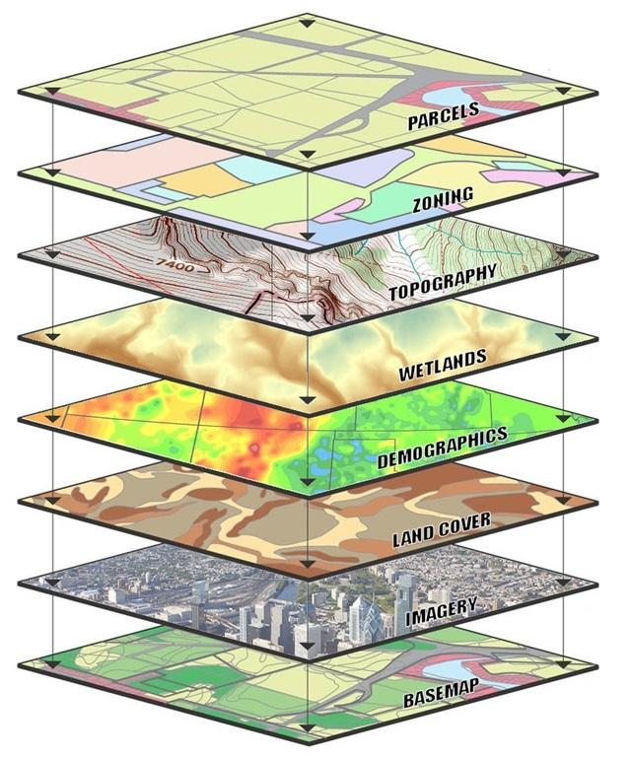

Meeting with ESRI representatives

- Met with regional head of ESRI for government entities in SE and regional rep for municipalities in NC
- Right off the bat: “It’s a geographic problem”, but it’s also a bureaucratic problem as agencies don’t talk to each other
- What ESRI does is offer software that DB’s get plugged into
- Kind of like Excel- powerful software that you put data into, imported data from other sources, your own data, to create your own solution to your own unique needs
- DOT uses it, Buncombe County GIS uses it, even we use it
- So, each agency or user (commercial too like Google Maps) has their own “recipe” of data bases for their unique applications
- Their recommendation: work with the Post Office and county
- Outlined seven action steps that we’re working on now, mostly information gathering
- It’s like eating an elephant-- One bite at a time

EMS/911
- Unable to enter Montreat physical in an Apple watch to take advantage of the 911 feature. The GIS coordinator at BC suggested using street address but enter Black Mountain 28711. Apple accepted that address. This will be important as more people invest in devices with a 911 feature.
- The new 911/EMS was to go into effect Nov 4 but it has been delayed. After talking to BC folks and our Black Mtn. fire chief, we feel certain that we will be accurately represented.

Covid-19
- Reported last meeting about getting connected with the Dir of DHHS for BC
- She introduced us to three folks in Raleigh who helped develop the COVID dashboard and reporting system. One was a chief scientist at CDC working with NCDHHS as head of data
- Had several phone conversations and a number of email exchanges
- Issue: why is our data suppressed? HHS, CDC and NCDHHS decisions
- Two responses:
  - Our population is too small to maintain confidentiality
  - ZIP code 28757 has a population of 0, thus can’t report data with a pop of 0
- Asked about nursing homes and child care organizations
- They said the CDC/DHHS regulations allow release of information in the interest of protecting public health
- Unlikely we will ever change it; our data will be aggregated with BC
- At least we have Montreat College’s excellent COVID-19 dashboard

Zip Code issue
Bottom line first – We do live in the 28711 Zip Code! Go to https://www.unitedstateszipcodes.org/ and type in 28711. You will see that 28757 is completely contained within 28711. Now type in 28757. Notice that our boundary runs along Flat Creek. The 28757 zip does not include anyone living on the east side of Flat Creek. So, if you live in the KY Road, Lookout, Shenandoah areas, you do not live in 28757. Also notice the population listing of 280 which would be their estimate for everyone on the west side of the creek.

- Zip Codes don’t define municipal boundaries
- US Census data does, but Zip Codes not so
- Look at a zip code map of Montreat and depending on which one you’re looking at, could be northern half of Montreat, small area around the Post Office, or any number of other iterations- all dependent upon who is presenting the information
- We asked NCDHHS to use our US Census codes instead of Zip Codes since it accurately defines ALL of Montreat. They ignored my question- both times I asked it!

From the beginning, we were in search of the main source of our problems in hopes that correcting the main source would set up a trickle-down effect that would take care of everything on our list. While the problem is more complex than that, we feel like the USPS is at the heart of our situation.

Tim Bryson, our Postmaster, spent many hours, even on his own time, to link each of our physical addresses to our PO Boxes. With the information complete, he sent it to Charlotte to our regional USPS. He was told that the information he compiled could not be entered into the system because PO boxes are not permanently tied to a residence. If I move, my PO box is assigned to someone else at another address. So, we had come to a dead end with our local USPS and in Charlotte. Tim is now working in Charlotte until January and it was his hope that he and the head of that organization could have some conversations. We have our fingers crossed.

We are also reaching out to elected officials:
- One of the action items from our meeting with ESRI was contacting elected officials at the Federal level re. the Post Office
- Tim Bryson didn’t get anywhere with his regional office in Charlotte, but he will continue to pursue the matter
- Perhaps working from top down will work
- We are trying to arrange audience with staff of our two US Senators, Burr and Tillis, and US Representative McHenry. Maybe they can help us get through the geographic and bureaucratic issue

Our next appointment is with the GIS coordinator at BC. He is well aware of our situation and has been working on it for the last decade. We do not expect him to provide a solution, but do hope he can look at our findings and possibly suggest next steps.

In summary, we appreciate the work of those who have gone before us. We are feeling more hopeful, but this problem has been around for a long time. Zip Codes were assigned in 1963 to define territories for postal sectioning. The creators had no idea about the future technology that would use their codes for so many other purposes. Problems with Zip Codes are ours, not theirs, and this is not just a Montreat problem. There are communities all over the country, and even within Buncombe County that have to deal with Zip Code issues. This has been like starting a small ball of snow and rolling it down a hill. The problem is huge and increasingly complex with the development of new technologies. It will not go away anytime soon.

Maybe the most important thing we convey now, is that we need everyone to be patient. Please, please, do not think you can help by doing your independent investigations that involve contacting people with whom we are working. Trust us to continue working and keeping you informed. We have already encountered people who are experiencing “Montreat Address” fatigue.

Until the issue is resolved, maybe we just need to accept the fact that, according to the county and state, we do live in the 28711 Zip Code. Hopefully, we will, one day, be able to align the data to better represent us in Montreat 28757.

