Thank you for your interest in completing your 2020 census. If you do not want to wait for a census package to be delivered to your home, you may go online or call them by phone to complete your census questionnaire without a unique Census ID number. Here are instructions in doing so.

- Go to https://my2020census.gov/login.
- Notice at the bottom of the page a link entitled “If you do not have a Census ID, click here.”
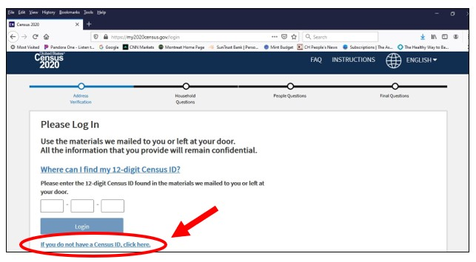

- Then, follow the registration questions, which will in turn lead you to the actual census form. It will take less than 8 minutes to complete the census online. Please remember that the Census Bureau works from street addresses, not PO Boxes, so please use your street address.

If you do not have online access or don’t wish to complete the census in that manner, you may do it over the phone by calling 844-330-2020 and completing by phone. Note that the Census Bureau has had to reduce staff so the wait may be long.

