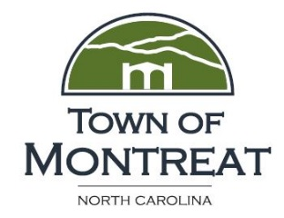 Currently Active Capital Improvement Projects
Town Hall | Under contract. Phase 1, preliminary designs, complete. Phase II, construction drawings and final budget, winding down. Phase III, construction expected to begin this summer.
Public Works Building | Site Prepared. RFQ published on 3/4, closes on 3/29, informational meeting on 3/18.
Texas Rd. Pedestrian Bridge | RFQ for design services closed on 2/11. Contract negotiations underway with Vaughn & Melton.
Texas Rd. Waterline | Expected completion date 3/21
Texas Rd. and Calvin Trail Paving | Project awarded in the fall ‘18- expected completion in early spring
Frist Rd. Paving | Project awarded in the fall ‘18- expected completion in early spring
Wells A & B Chlorine Retrofit | In process. Expected completion date 4/4.
Well 6 Pump Conversion | In process. Expected completion date 3/21.
Assembly Drive Culvert and Crosswalk | In process. Expected completion date 3/18.
Tennessee Rd. Culvert and Catch Basin | In process. Expected completion date 3/21.
South Carolina Terrace Parking Area | Engineer assessed - Expected completion 4/4.
Kentucky Rd. Culvert | Engineer assessed - Expected completion date 4/25
South Carolina Terrace Culvert | Engineer assessed - Expected completion date 4/11
Wyck Rd. Culvert | Engineer assessed - Expected completion date 4/18
Lower Greybeard Wall and Creek Stabilization | RFQ re-published on 2/28, closes on 3/20.
Suwannee Mudslide | Engineer assessed - RFQ pending.
Texas Road Extension Culvert and Barrel -1 | Engineer assessed - RFQ pending.
Texas Road Wall and Bank Stabilization (Below Pool) | Engineer assessed - RFQ pending.

